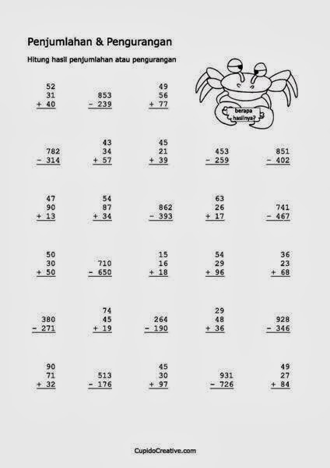

**Sčítanie a odčítanie pod seba**

**Počítame do 100** Meno: .................................................

Označ krížikom, či je výsledok správny **ÁNO** alebo nesprávny  **NIE**.

Ak označíš, že je nesprávny, tak vedľa napíš správny výsledok:

|  |  |  |  |  |  |  |  |
| --- | --- | --- | --- | --- | --- | --- | --- |
|  | **Á** | **N** | **Spr.** |  | **Á** | **N** | **Spr.** |
| 24 + 18 = 32 |  |  |  | 72 – 23 = 49 |  |  |  |
| 45 – 12 = 33 |  |  |  | 37 + 19 = 66 |  |  |  |
| 56 + 27 = 82 |  |  |  | 50 – 15 = 25 |  |  |  |
| 80 – 35 = 45 |  |  |  | 93 – 63 = 30 |  |  |  |
| 42 + 26 = 68 |  |  |  | 64 + 16 = 70 |  |  |  |
| 53 + 38 = 81 |  |  |  | 15 + 48 = 63 |  |  |  |
| 79 – 39 = 50 |  |  |  | 85 – 29 = 56 |  |  |  |
| 96 – 45 = 51 |  |  |  | 66 – 42 = 24 |  |  |  |
| 37 + 38 = 85 |  |  |  | 29 + 64 = 94 |  |  |  |
| 21 + 68 = 79 |  |  |  | 95 – 78 = 17 |  |  |  |

**Doplň chýbajúce násobky čísla 2:**

**2 6 12 14 18**

**Vypočítaj:**

60 30 42 59 74 21 67

20 5 30 7 5 9 4

___________________________________________

70 69 33 50 96 77 41

-50 - 4 - 7 - 9 - 3 - 20 - 8

___________________________________________

30 + 50 =___ 100 - 70 =___

20 + 41 =___ 78 - 40 =___

32 + 4 =___ 59 - 5 =___

78 + 5 =___ 62 - 9 =___

46 + 4 =___ 30 - 5 =___

22 + 7 =___ 67 - 6 =___

88 + 7 =___ 61 - 9 =___

5 . 3 =___ 10 . 2 =___

9 . 2 =___ 7 . 0 =___

6 . 3 =___ 5 . 1 =___

8 . 2 =___ 7 . 3 =___

4 . 3 =___ 9 . 3 =___

2 . 2 =___ 10 . 1 =___

3 . 3 =___ 5 . 3 =___

Počet chýb:

14 : 2 =___ 9 : 1 =___

20 : 2 =___ 9 : 3 =___

15 : 3 =___ 18 : 2 =___

24 : 3 =___ 3 : 3 =___

10 : 1 =___ 16 : 2 =___

17 : 3 =___ 18 : 3 =___

5 : 1 =___ 12 : 2 =___

**Počet chýb:**

**Vypočítaj:**

5 . 3 =___ 12 : 2 =___ 2 . 2 =___

9 . 2 =___ 21 : 3 =___ 18 : 3 =___

4 . 0 =___ 3 : 3 =___ 7 . 2 =___

8 . 2 =___ 15 : 3 =___ 9 . 0 =___

7 . 3 =___ 27 : 3 =___ 30 : 3 =___

7 . 2 =___ 14 : 2 =___ 8 . 1 =___

33 + 5 =___ 96 - 4 =___ 45 29 33 74 91 65 21

57 + 8 =___ 62 - 7 =___ 3 50 7 9 5 8 9

28 + 2 =___ 40 - 8 =___ _____________________________________________

20 + 50 =___ 80 - 50 =___

47 - 30 =___ 67 - 50 =___

52 + 4 =___ 37 - 2 =___ 38 51 40 28 76 54 89

66 + 4 =___ 41 - 5 =___ - 4 - 7 - 3 - 7 -30 - 9 - 8

28 + 5 =___ 60 - 7 =___ ______________________________________________

5 + 21 =___ 38 - 31 =___

Počet chýb: HARPFACE